 

Q1:

Software Requirements Specification

for

Bird Boarding Booking System

Version 1.0 approved

Prepared by

Nguyen Hoang Thai – HE176588

FPT University Ha Noi

02/04/2024

Q2:

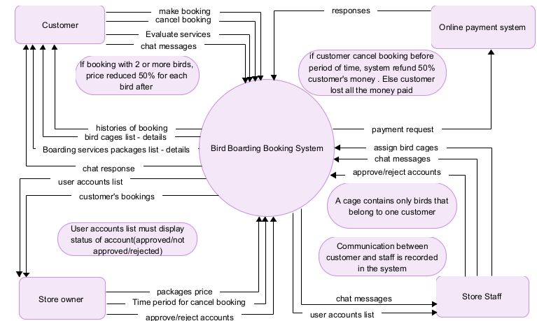

Q3:

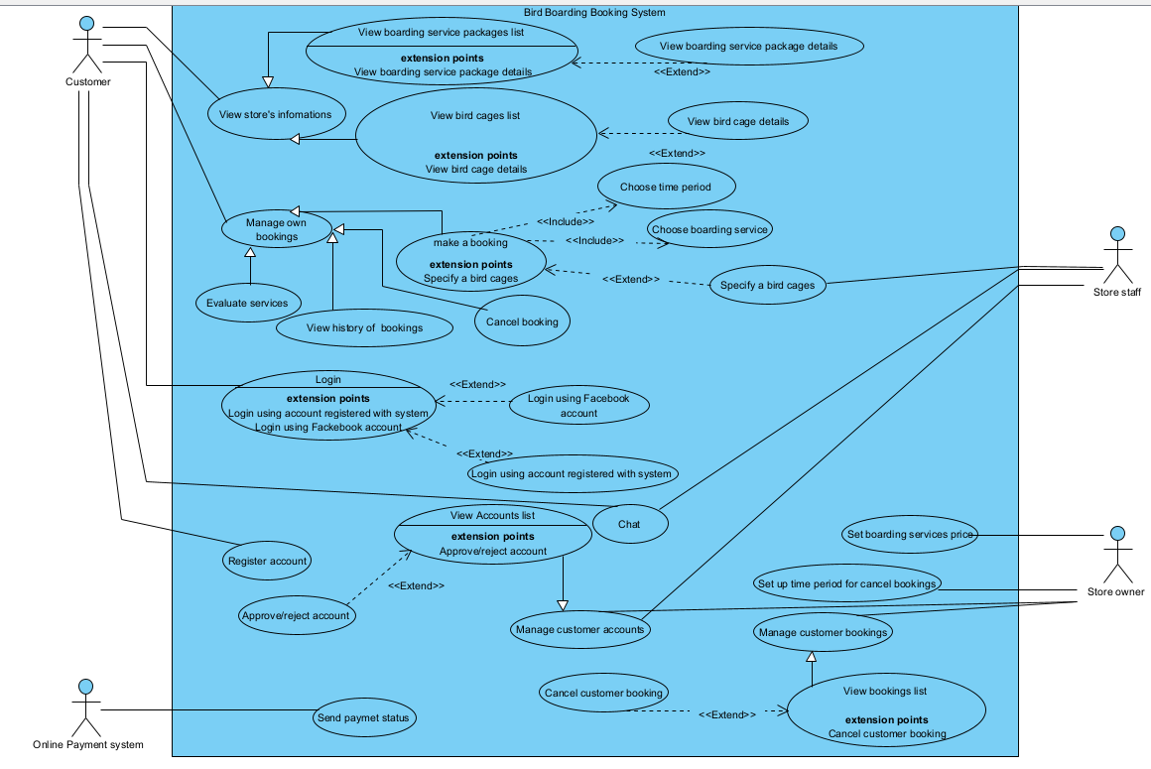

|  |  |  |
| --- | --- | --- |
| **#** | **Actor** | **Description** |
| 01 | Customer | Customer who login the system to make booking for birds boarding services during busy periods, view booking history, chat with staff and evaluate the services. |
| 02 | Store staff | Who login the system to response customer chats, assign bird cage if customer don’t specify a cage and approve customer accounts. |
| 03 | Store owner | Who login the system to set up store information like: services price, time period for cancel, manage customer’s bookings and accounts. |
| 04 | Online payment system | External system which user used for paying the booking. It will send status of payment to system. |

|  |  |  |  |
| --- | --- | --- | --- |
| **#** | **Use Case** | **Actors** | **Description** |
| UC-01 | View bird cages list | Customer | Customer view bird cages available in the store. |
| UC-02 | Cancel booking | Customer | Customer cancel their booking that has been booked. |
| UC-03 | Register account | Customer | Customer create their own account with username and password in the system. |
| UC-04 | View Accounts list | Staff, store owner | Staff or Store owner view customer’s accounts list. |
| UC-05 | Approve/reject account | Staff, Store owner | Staff, Store owner approve or reject customer’s account. |
| UC-06 | Login using account registered with system | Customer | User login the system with account registered. |
| UC-07 | Make a booking | Customer | Customer after login to system can make a booking for bird boarding services by choose the time and service. |
| UC-08 | View history of bookings | Customer | Customer views their booking history. |
| UC-09 | Set boarding services price | Store owner | Store owner set the services price |
| UC-10 | Set up time period for cancel bookings | Store owner | Store owner Set up time period for cancel bookings. |
| UC-11 | Login using facebook account | Customer | Customer use their fackebook account to login to system. |
| UC-12 | Send payment status | Online payment system | Online payment system send payment status to system. |

Q4:

|  |  |  |
| --- | --- | --- |
| ID | Rule Definition | Use cases |
| BR-01 | Customer can only view the AVAILABLE bird cages in store. | UC-01 |
| BR-02 | Customers cancel before time period (which set by the owner) lost 50% money. After that they lost all money. | UC-02 |
| BR-03 | Customer’s registered account must be approved by staff or owner to be able to login to system | UC-05, UC-04 |
| BR-04 | lock a customer’s account after 5 consecutive unsuccessful logon attempts within period of 5minutes. | UC-06 |
| BR-05 | If user booking with two or more birds in a cage, price reduced by 50% for each additional bird. | UC-07 |

**Q5:**

* 95 percent of customers who have never used the Bird Boarding Booking system before shall be able to place a booking correctly with no more than 15 minutes of orientation.
* -The system shall be at least 99 percent available between 6:00 A.M and midnight, and at least 95 percent available from midnight to 6:00 A.M.
* Webpages shall fully download in an average of 2 seconds or less over a 30 megabits/second Internet connection.